  We invite you to use this guide to prepare for your CCSP exam! | 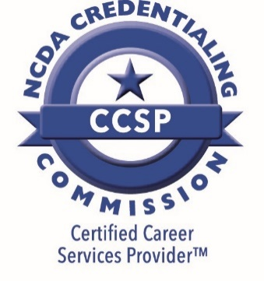

What competencies are measured in the credential?
The CCSP assessment is designed to assess an individual's competency by assessing knowledge of the learning objectives of the NCDA's Facilitating Career Development Training Program curriculum. Check out the credentialing website for a review of the competencies for this credential.

What will the assessment be like?
- The assessment consists of 80 multiple choice questions spanning 6 subject areas that are tied directly to the FCD Student Manual:
  - Module 1: Developing a Helping Relationship (15 items)
  - Module 3: Career Development Theory and its Application (19 items)
  - Module 4: The Role of Assessment in Career Planning (16 items)
  - Module 5: Ethics and the Career Services Provider (7 items)
  - Module 6: Providing Career Services to Multicultural Populations (8 items)
  - Module 8: Job Seeking and Employability Skills (15 items)
- Before starting the assessment, there is a short ungraded sample quiz to help acclimate you with the online testing environment. It contains 5 quiz questions that are not scored and do not count towards your CCSP exam grade
- You have 120 minutes (2 hours) to complete the assessment once you start (not including the sample quiz). The timer remains visible while you complete the assessment, and there is no way to pause the timer once it starts.
- While you can not go back to previously answered questions, you can mark as many items as you like for review so you can revisit them later before finalizing submission of the assessment.
- The questions are derived directly from the FCD student manual. However, using the manual or any other materials while taking the exam is prohibited.

How can I prepare?
- Review the FCD student manual, particularly modules 1, 3, 4, 5, 6, and 8, as all questions are derived from the student manual.
  - Be sure to review the appendix in each module in addition to the main text.
- You are likely to find you can answer some questions quickly, while others will take more thought. Have a strategy in mind for how you will manage this.
- Remember that the assessment platform records your response as soon as you select an answer. If you did not mark the question for review, you will have no way change your response later – even if you clicked on the wrong answer by accident.
  - THEREFORE, it is recommended that you click the “Review” checkbox for every question before you select an answer.

