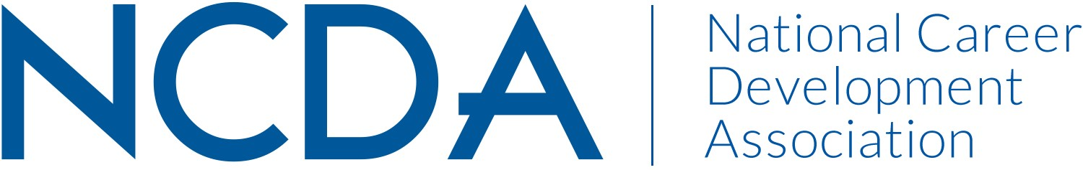

NCDA Mid-Year REPORT

CAREER CONVERGENCE WEB MAGAZINE
March 15, 2025

Editor: Melanie Reinersman, webeditor@ncda.org
Associate Editors: Natasha Barnes, Brittany Collins, David Dietrich, Jane Frisch, Candina Janicki, Vonya Hodrick, Maisie Lynch, Meredith Montgomery, Elyse Pipitone, Billie Streufert
Field Editors: Mason Murphy, Willa Smith, Regina Gavin Williams

Committee Activities to Date

- Published new issues on the first of each month (except Jan.) bringing the total issues up to 228, since 2003 (Strategic Goal #2- Career Empowerment: Publications)
- Published 7 new articles, plus one Tech Tip, each month. Electronic distribution to over 25,000 emails on the first of the month and about 1700 articles archived
- Investigated and achieved Board approval for new auditory player plug-in, so articles can be played anytime (Strategic Goal #1- Community: Engagement)
- Held virtual call with editorial team on December 18, 2024 (Strategic Goal #1- Community: Engagement)
- Considered Multiview’s offer to place advertisements in web magazine (Strategic Goal #1- Community: Create new networking opportunities.)
- Noted a Field Editor’s resignation, effective in June; Connected with 2 potential Field Editors (Strategic Goal #1- Community: Engagement)
- Selected winner (by editors’ votes) the annual “Career Convergence Recognition Award” – Allison Levine, winner (Strategic Goal #1- Community: Engagement)
- Published articles in cooperation with NCDA committee, e.g., a series from the Global Career Connections Committee (Strategic Goal #1- Community: Engagement)
- Social media each month handled by NCDA Social Media coordinator, with links to the issue and each article (Strategic Goal #1- Community: Recruitment)

Projected Plan/Work Planned to be Completed through September 30.

- Continue to publish monthly issues of the web magazine
- Install auditory plug in for listening to articles
- Follow up with 2 potential Field Editors
- Move forward with Multiview’s offer to place advertisements in web magazine
- Hold a committee meeting at the NCDA conference in Atlanta in June.

