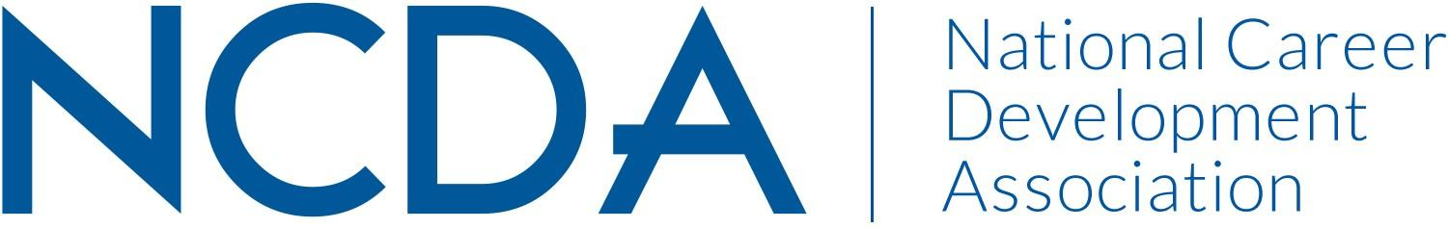

NCDA COMMITTEE REPORT

AWARDS COMMITTEE
March 15, 2025

List of Chair and Co-Chair(s)
Delasia Rice drice13@fordham.edu
Emily Gomez egomez@hireheroesusa.org

List Committee Members

Soonhoon Ahn
Nicole Anderson
Jessica Ayub
Amanda Cox
Scott Fisher
Sujata Ives
Kenyatta Jonhson
Natalie Kauffman
Kelvin Ling
Elvis Sio
Zhadoi Wang

Committee/Council Activities to Date

- New Co-Chairs were selected
  - Delasia Rice began October 2024
  - Emily Gomez began March 2025
- Award Nominations opened December 18th and were due January 31st (there was no extension offered this year)
- Published piece in December 2024 Career Convergence Titled “NCDA Awards x Strategic Plan: More than One Empowered Individual” (strategic plan: career empowerment)
- Met as a committee in January 2024 to introduce new co-chair and discuss plan on award nomination and selection
- Split selection meetings into two: one took place March 18th, the other took place March 23rd
  - during last selection meeting, committee discussed potential changes that could be made to the award selection process including changes to the rubric, changes to the awards, changes to the webpage, and updated written policies for future nominees

Projected Plan/Work Planned to be Completed through September 30.

- Award committee co-chairs will send out emails to Award winners as well as those who were not selected
  - For those who were not selected, co-chairs will recommend meeting prior to next round of awards due to know what can be improved within award packet
- Co-chairs will meet with board liaison to discuss projected changes to award nomination and selection process that can be implemented prior to the opening of the awards for the next cycle
- Committee will reconvene in August of 2025 to discuss changes and come up with a proposal to submit to the Board by September 2025

