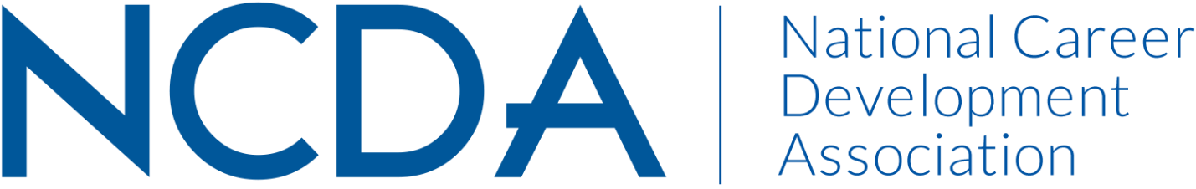

ETHICS COMMITTEE MID-YEAR REPORT
March 15, 2025

Co-Chairs:
Conquaya James, MS & EdS  ConquayaJames@hotmail.com  478.241.0466 | David Reile, PhD  David@reile.com

Committee Members

Amanda Chenkin
Amy Policastro- Schroeder
Angie Smith
Azra Siwiec
Becca McCarthy
Billie Streufert
Chris LaFever
Dan Greenwood
Diane Farrell
Duke Wallin
Gillian Johnston
Jaana Kettunen
James Westhoff
Keith Okrosy
Keley Smith-Keler
Lisa Sweet
Manpreet Kaur
Marie Nicks
Mary Guirovich
Michi Mizuno
Ron Cathey
Sarah Patterson- Mills
Sharon Anderson
Shundrika Morris
Stacy VanHorn
Tanisha Stokes
VL Muanpuii

Activities to Date

- Received and responded to zero ethical inquiries from NCDA members (GOALS: Cultivating Community & Advocacy)
- Submitted “Ethics in a Nutshell” and featured articles for the Career Developments magazine (GOALS: Cultivating Community, Career Empowerment, & Advocacy)
- Conducted two NCDA webinars, one on Ethics and another on private practice (GOALS: Cultivating Community, Career Empowerment, & Advocacy)
- Worked with NCDA President, Marty Apodaca, to form an AI Task Force and to determine work parameters (GOALS: Cultivating Community, Career Empowerment, & Advocacy)

Projected Plan through fiscal year end (September 30th)

- Respond to ethical inquiries
- Write “Ethics in a Nutshell” and Focus articles for the Career Developments magazine
- Recruit new members and prepare for the upcoming year
- Work with Marty Apodaca and additional members of the AI Task Force

Budget Requests: N/A

