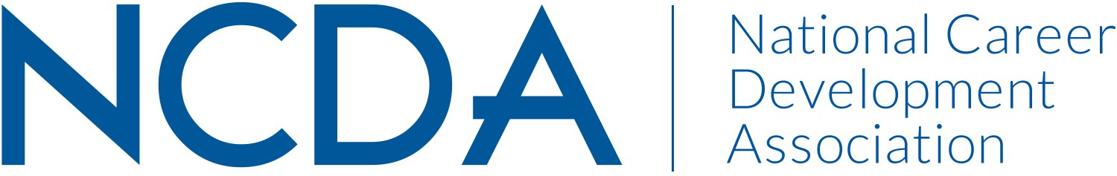

NCDA COMMITTEE REPORT

DIVERSITY INITIATIVE & CULTURAL INCLUSION COMMITTEE
March 25, 2025

List of Chair and Co-Chair(s)

Dr. Natasha Barnes-Gwynn – natashabarnes.ed.d@gmail.com
Ruben Britt – britt@rowan.edu

List Committee Members

Markell Morris – board liaison
Dr. Alicia Monroe – informed practices sub-committee chair
Dr. Nathaniel Brown – informed practices sub-committee chair
Dr. Cheryl Love – training sub-committee chair
Dr. Frank Gorritz-FitzSimons - training sub-committee chair
Sarah Pearson – online resources sub-committee chair
Casey Dozier - online resources sub-committee
Dr. Nina Talley – career practitioners of tomorrow sub-committee chair
Denise Felder - career practitioners of tomorrow sub-committee chair
Dr. Christian Chan – multicultural competencies task force

Approximately 117 members on the roster presently

Committee/Council Activities to Date

-Online Resources subcommittee continues to keep online resources up-to-date for members and non-members; DEI and Career Calendar has been made available for members online as well – Objective 1A & 3B
-Informed Practices subcommittee continues to support publications in Career Convergence and other professional journals; DICI newsletter continues to be published – moving to a quarterly issue – Objective 1B & 2C
-Training Subcommittee continues to support the DEI Symposium for the 2025 NCDA conference and the DEI podcast series hosted by NCDA – Objectives 1A & 3B
-Career Practitioners of Tomorrow – this is a new committee seeking to engage students and new professionals in DEI and career development work – development is ongoing for this committee – Objectives 2A & 3B

-Multicultural Competencies Task Force – currently working to develop new multicultural competencies – first draft is being completed for review by DICI committee.

Projected Plan/Work Planned to be Completed through September 30.

-DEI Symposium to happen during the 2025 NCDA Conference
-Full development of the Career Practitioners of Tomorrow subcommittee by September 30th.

