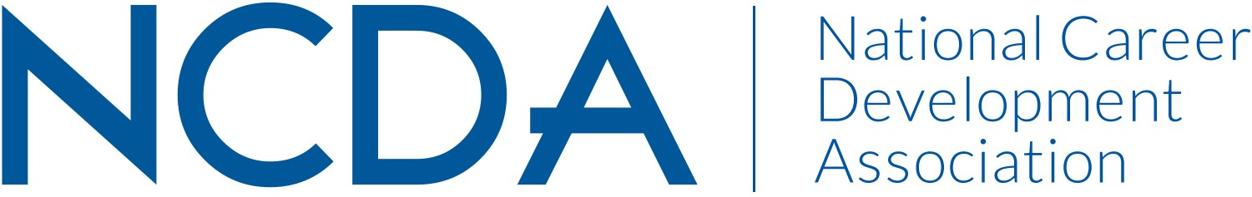

Board Travel for State CDA Events (Effective Date: October 1, 2024-2027)

Summary:
The purpose of this document is to outline guidelines for board member travel to state CDA events. NCDA provides monetary support for board members travel to state CDA events to be speakers on topics selected by the state CDA. *Note: When representing NCDA and/or travelling with support from NCDA, Board Members will not accept a stipend. Board members are not able to accept any form of payment or honorarium for their speaking engagements.

Guidelines:
Funds available for board member travel will vary by NCDA budget year. The number of funded board member travel will be based on the budget available each year.

State CDA travel requests will be evaluated based on the following criteria:
- Economical use of NCDA funds and effective use of board member time at the event
- State CDA fund contribute to the overall event
- The concept of the event is detailed and shows alignment with board member expertise/speaking areas
- Timing of event – can’t conflict with board member travel to NCDA board meetings

Deadlines:
- These will be announced each year and will generally be October 1st for spring and summer events and July 15th for fall events, but these dates can change.
- Be sure to read all e-mails received from the State Trustee for most accurate deadlines.
- Evaluation priority will be given to those state CDAs who submit by the deadlines. However, if travel funds remain and a state CDA submits after the deadlines, those will be considered.

Reminders:
- Be sure to completely fill out the NCDA Speaker Request Form and submit that through the NCDA portal PRIOR to contacting any Board member for speaking engagement.
- Include specific dates and times, length and expectation of board member. Include travel dates and hotel name and address connected to the CDA event, along with any finances that the CDA will cover.
- Priority will be given to those state CDAs who submit their requests early. Include a fist and second preference and

Questions: Please contact the State Trustee, Markell Morris at markell@futures-in-motion.com

